HOW TO CLEAN YOUR 30GB GMAIL ACCOUNT
(PLEASE PRINT THIS DOCUMENT FOR THE BEST VIEWING OF SCREEN SHOTS)
All Email (sent or received) is backed up via a service called Postini. This is done automatically. Thus, all email can be restored in the event of loss. Your mailbox is another of copy of everything we already have in archive. Thus, you can clean with the comfort of knowing we already have a copy of your mailbox offline.
Removing your Largest Emails
- Log into your FPI Gmail Account.
- Click the arrow to allow you to use the search features built into Gmail.
- Select the following criteria & then press the blue magnifying glass button
  - Has attachment
  - Larger than 10MB
  - Date within a Year
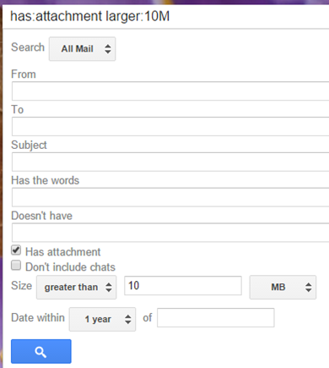

- Review all returned items
  - Save out any Attachments as needed to a local or network drive.
  - Print out any emails with large attachments as a PDF if they need to be kept long term.
  - Select all of your emails with large attachments by using the select all button and press the delete or garbage can icon.

Searching for your Oldest Emails
- To search for old items, you may type in a date range to search for in the search field. Let’s say I wanted to search for all emails from 2010-2013.
  - Type the following in the search field
after:2010/1/1 before:2013/12/31
  - Press the blue find button.

  - Review your older emails and delete as needed.

Searching for emails from Particular Staff
Does Sally send you lots of large files? It may be easiest to clean up emails from one particular person to make a big dent on your inbox.
- Click the arrow to allow you to use the search features built into Gmail.
- Select the following criteria & then press the blue magnifying glass button
  - Fill out the user’s email address in the from field
  - Press the blue find button
- Review all items and delete as needed

Need Assistance?
Please open a ticket with IT at http://helpdesk.fpimgt.com

